Ideation Phase
Empathize & Discover

Date | 27 August 2026
Project Name | Employee Raise Issue
Maximum Marks | 4 Marks

Empathy Map Canvas:
The empathy map helps us understand the thoughts, feelings, needs, and challenges of employees regarding salary raise issues. Employees may feel confused and frustrated when they do not have a clear way to submit or track their concerns. This understanding helps us design a simple system where employees can submit their raise issues, track their status, and receive timely updates.
Example:
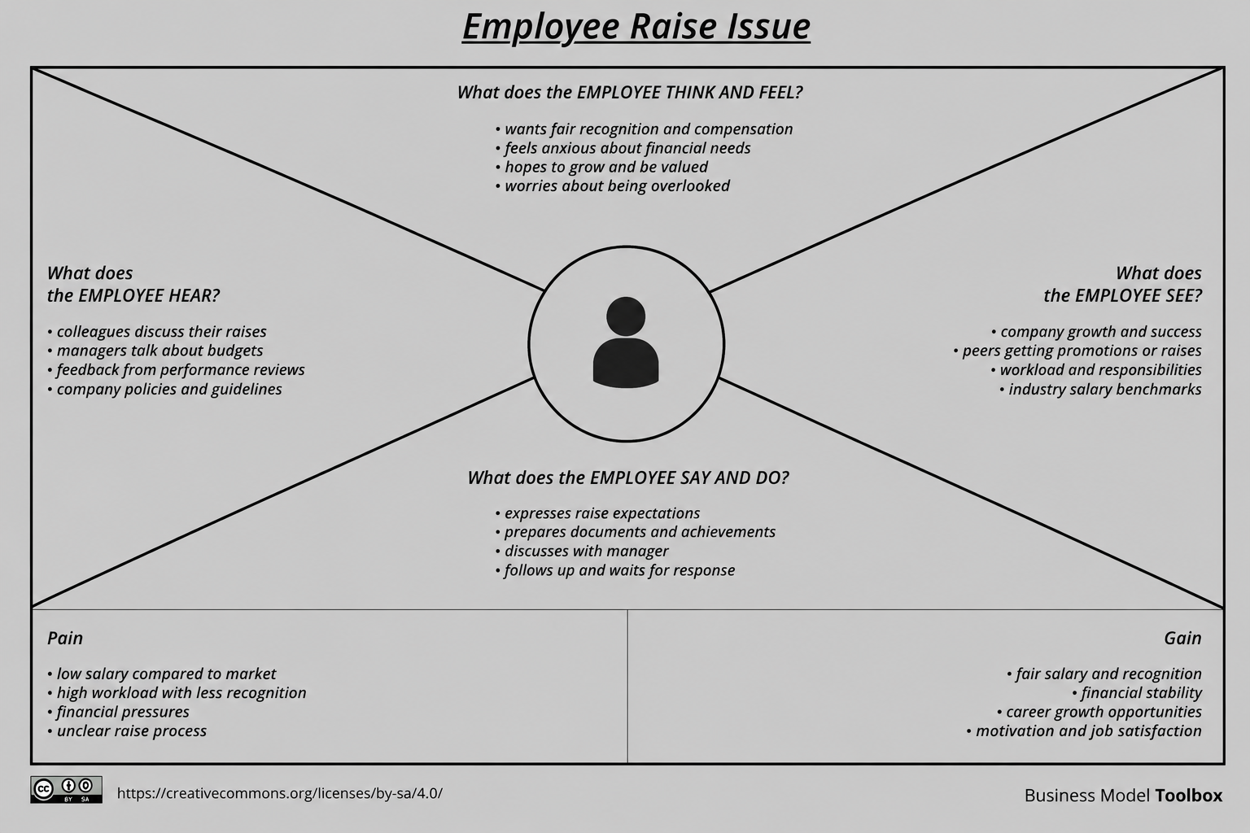

Example: Food Ordering & Delivery Application
